Defense Information Systems Agency (DISA)

Global Command and Control System – Joint (GCCS-J)

Ozone Mobile Users Guide

Release 1.0 / v1.0 - Revision 1



25 June 2014

Prepared For:

DISA Global Command and Control System – Joint

GCCS-J Program Management Office (PMO)

6914 Cooper Ave

Fort Meade, MD 20755-0549

Prepared By:

42six, a division of Computer Sciences Corporation

6630 Eli Whitney Dr

Columbia, MD 21046

DISTRIBUTION – Distribution authorized to DoD and DoD Contractors only; for administrative/operational use (31 Jan 2011). Other requests for this document shall be referred to the JC2CUI Program Management Office.

DESTRUCTION NOTICE – For unclassified, limited documents, destroy by any method that will prevent disclosure of contents or reconstruction of the document.

DISCLAIMER: This document is intended to document the application programmer’s interfaces created as part of the DISA Ozone Mobile effort. It will be updated and changed throughout the duration of the project, and should serve only as a reference until such time as this disclaimer is removed.

# Table of Contents

## Introduction

Table of Contents 2

Introduction 4

What is Ozone Mobile? 4

Key Design Elements 5

Program Workspace 6

Signing into your account 6

App Overview 8

How To 12

How to sync apps with OWF 12

How to create a composite app 12

How to delete a composite app 13

How to switch between apps in a composite app 13

How to delete an intent setting 14

How to add an app marketplace 14

How to download apps for offline usage 15

# Introduction

## What is Ozone Mobile?

Ozone Mobile is an extension of Ozone Framework for users allowing light-weight web applications on Android and iOS mobile devices.

* Runs the same widgets across mobile devices and desktop web browsers
* Supports connected and disconnected states
* Provides a common platform for widget developers

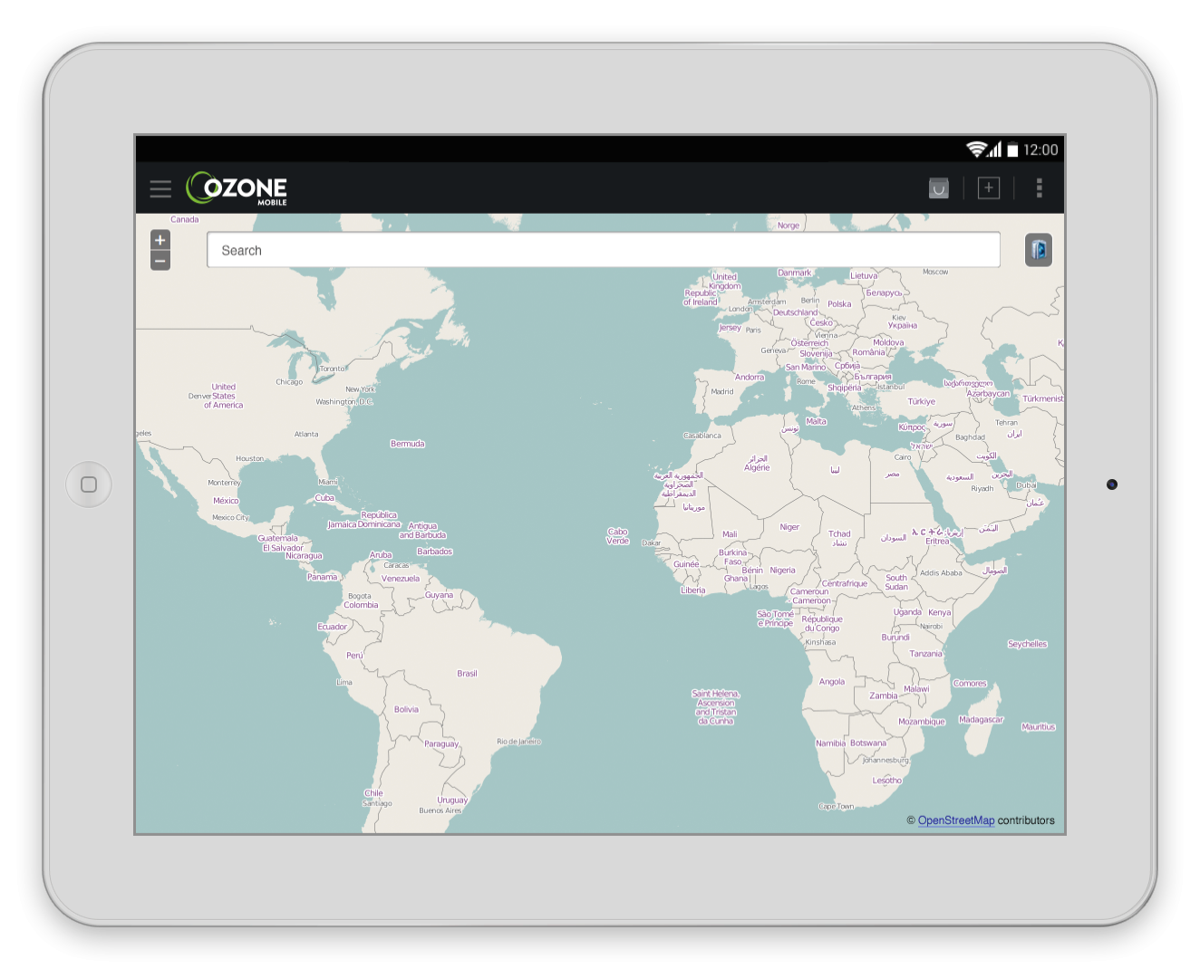

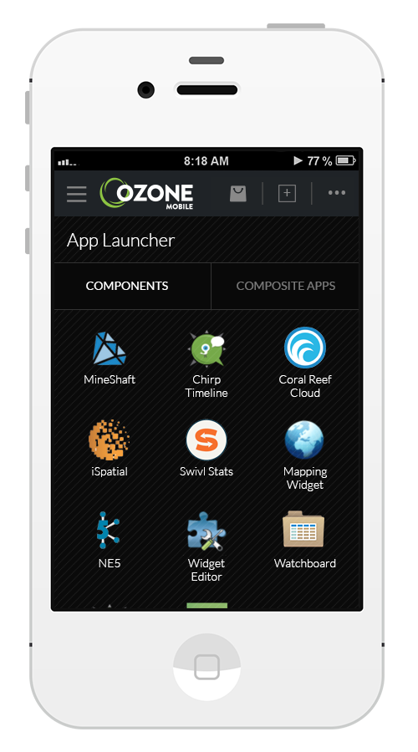

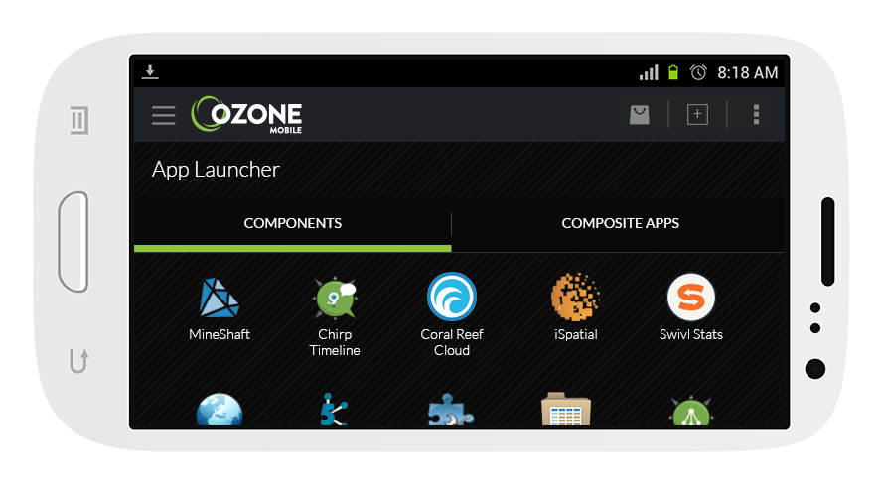

## Key Design Elements

**Ozone Mobile drawer menu** allows users to view and navigate through menus without leaving their current screen

**Ozone Mobile navigation/action bar** provides users a transparent level of information hierarchy while navigating through available screens. Also, the navigation bar contains additional links for users to navigate to ie. the AppsMall and AppBuilder.

**Flexible optimized layout** for multiple mobile devices and orientation

**App Launcher** provides instant access to available apps and users can navigate between components and composite apps

**Previewer Mode** allows users to switch between components in a composite app.

**AppBuilder** allows users to add/combine components to build a composite app

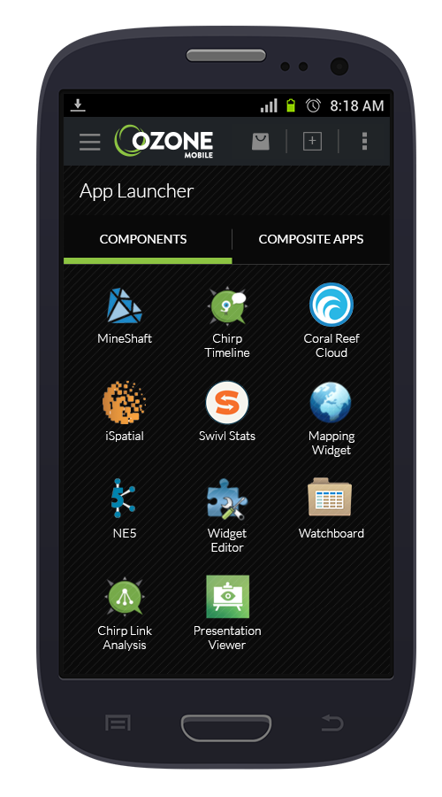

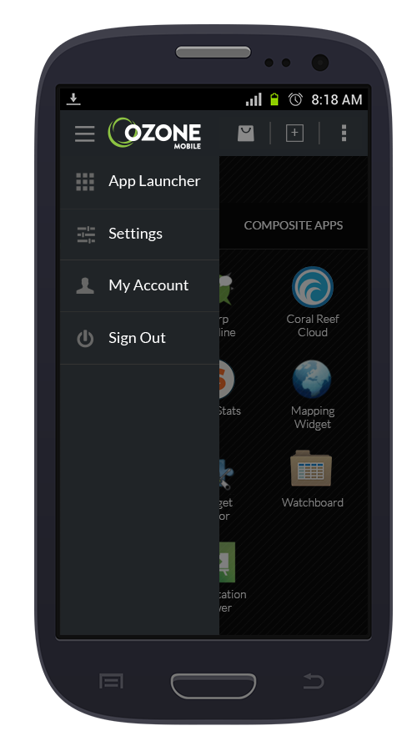

**Android App**

**iOS App**

# Program Workspace

## Signing into your account

Due to the differences between the two platforms, the login process for both types of devices is different.

**Android Sign In**

1) From your list of apps, select the Ozone Mobile application.

2) The application will open and prompt you to select a certificate. Your system administrator should have provisioned your device with your personal user certificate, and it will display here. If it’s not present, contact your system administrator. Select your user certificate and press “Allow.”

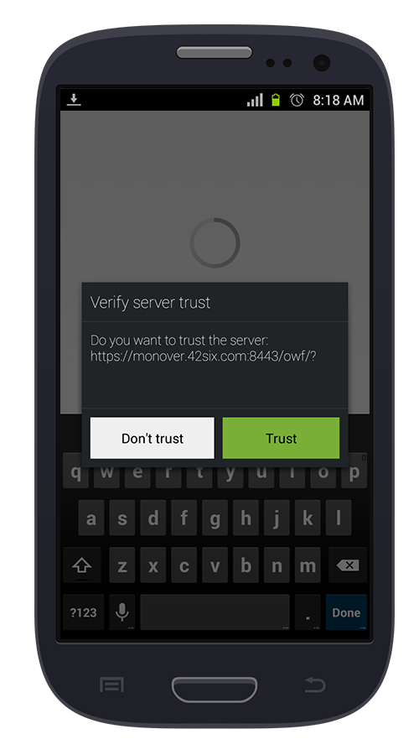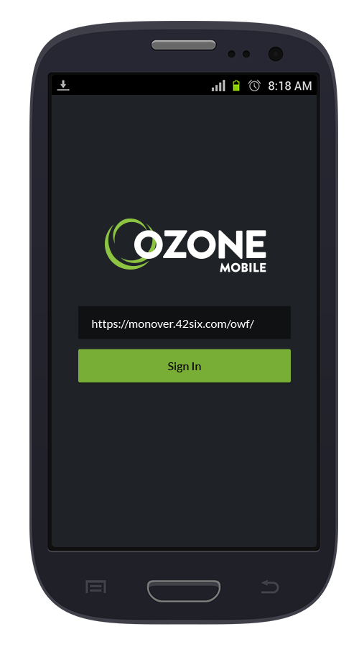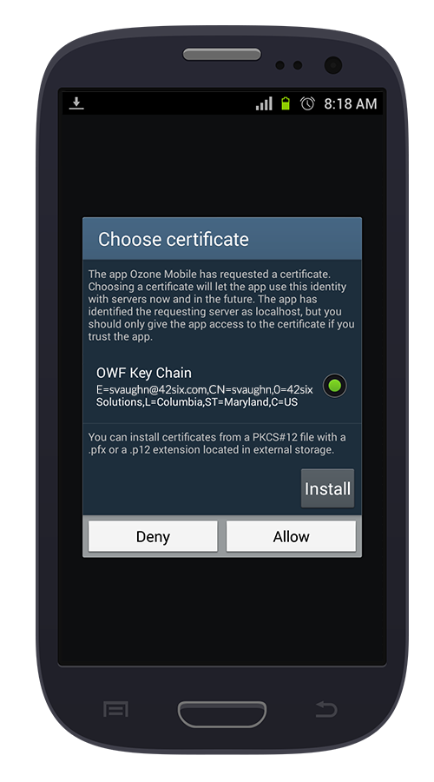

➔

➔

3) Select your user certificate and press “Allow.”

4) Type in the OWF server you’re attempting to connect to. Press “Sign in” to begin signing in.

5) Verify the server you are connecting to and press “trust” to finishing signing in to Ozone Mobile.

Sign in complete!

Type in the OWF server you’re attempting to connect to. Press “Sign in” to begin signing in.

**iOS Sign In**

1) To log into iOS, navigate to the Ozone Mobile icon on the home screen and press it.

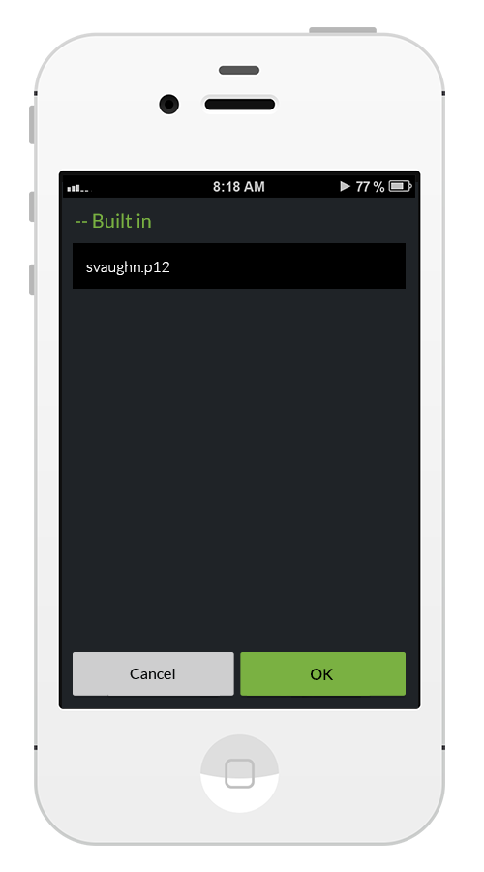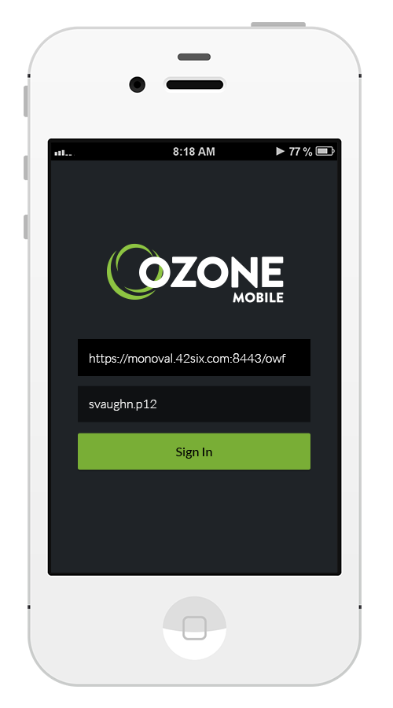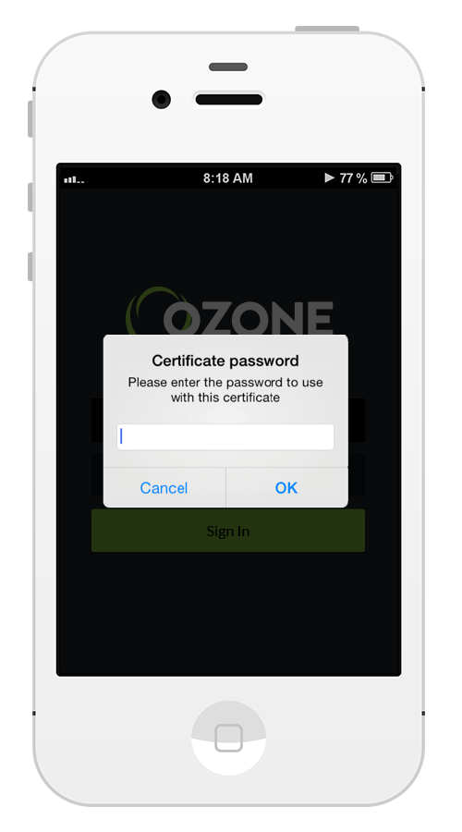

➔

➔

2) You’ll be presented with a Sign In screen that shows a server and selected cert.

If your cert is not already displayed, press the cert field on the screen.

3) This should open a certificate selection screen. Your system administrator should have placed your cert here. If you don’t see it, please contact them. Otherwise, select your cert and press “OK”.

4) Back on Sign In screen, modify the server field to make sure you’re connecting to the desired OWF instance, and tap “Sign In.” This will bring up a password prompt for the cert you’re using.

Enter the cert password and press “OK.” This will lead you to a the App Launcher screen.

You are signed in!

## App Overview

Ozone Mobile consists of 5 menu screens. **The App Launcher**, **Settings**, and **My Account** screens are accessible from the drawer menu. The **Marketplace** (AppsMall), and the **AppBuilder** are located on the action bar at the top of the screen.

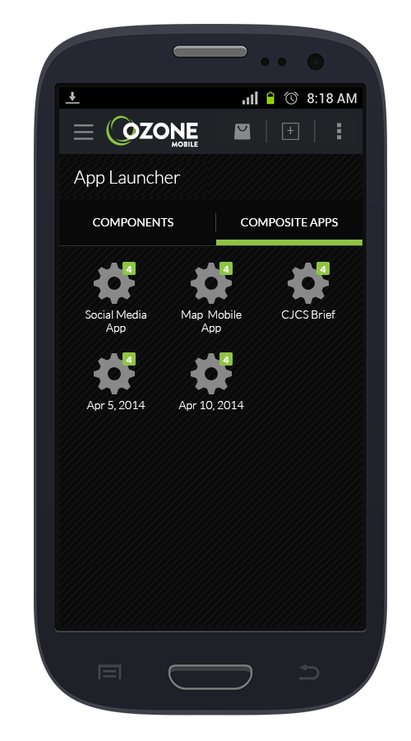

Component

Tabs - Users can view between components and composite apps

AppsBuilder

Overflow Menu

Ozone Menu reveals the drawer menu

O

Marketplace  
(AppsMall)

**App Launcher**

Composite app –badge on top-right corner indicates the number of components added

Components

Composite apps

**Settings**

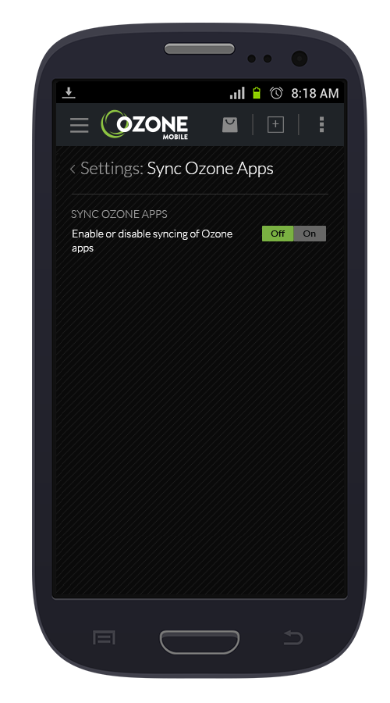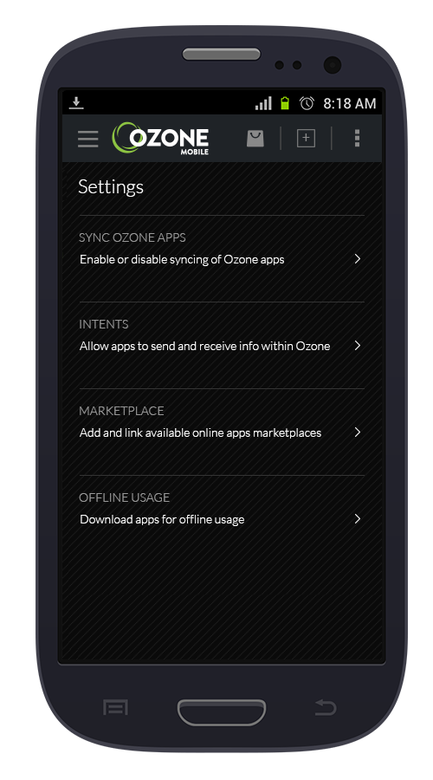

Sync Ozone Apps

Intents

Toggle switch – Enable or disable syncing of Oozne apps

Marketplace

Offline Usage

Settings Screen

Sync Ozone Apps  
(Sub-screen example)

**My Account Marketplace (AppsMall)**

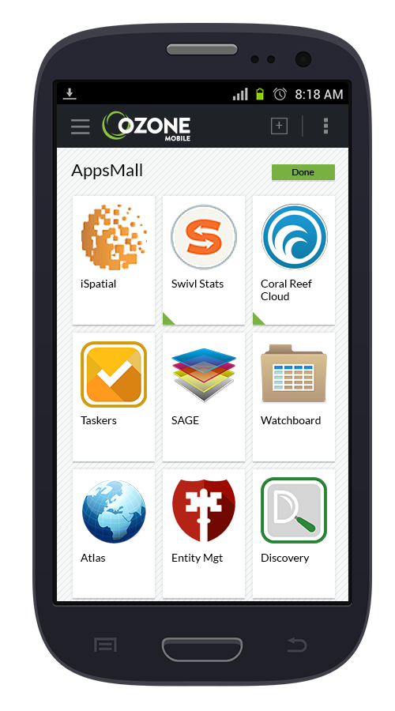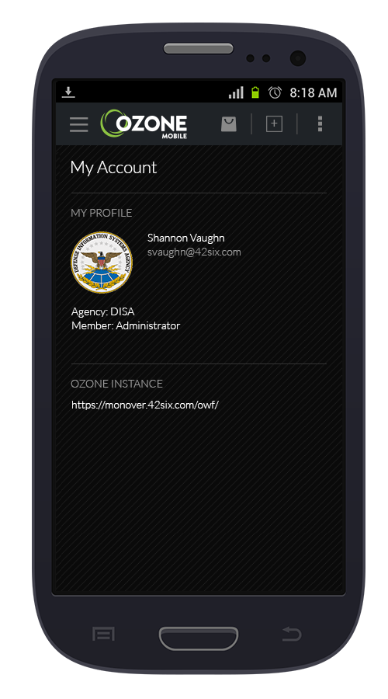

Indicator showing app has been added

Ozone Instance URL

App titles

**AppBuilder**

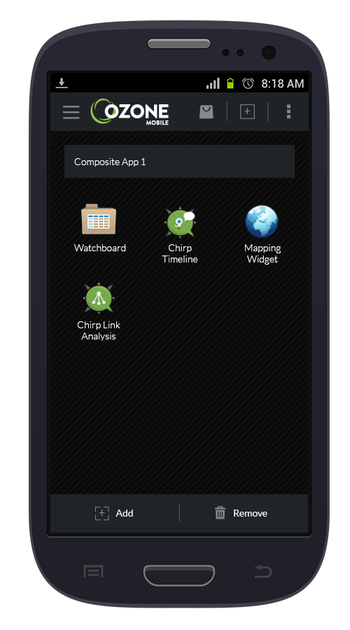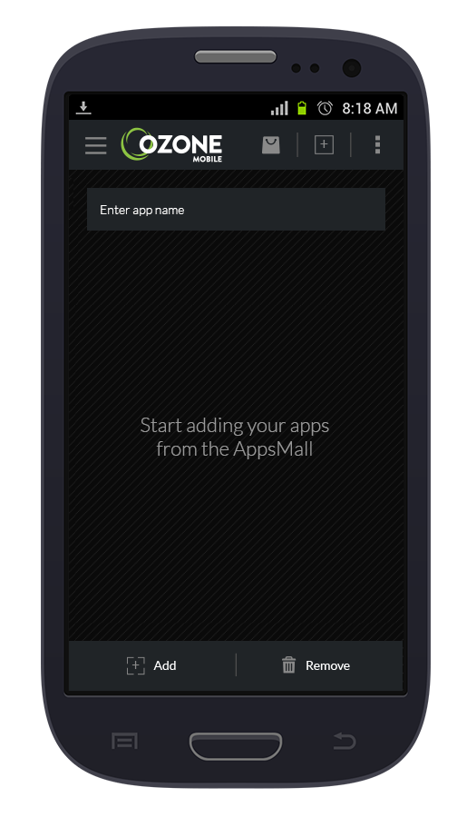

Enter app name here

Added app

“Remove” button to remove apps

“Add” button to add apps

AppBuilder screen with 4 apps added

AppBuilder start screen

# How To

## Macintosh HD:Users:ykim:Documents:Mono source files:Developer Toolkit:screens:android-settings1.png**Macintosh HD:Users:ykim:Documents:Mono source files:Developer Toolkit:screens:android-settings2.png**Macintosh HD:Users:ykim:Documents:Mono source files:Developer Toolkit:screens:android-applauncher2.pngHow to sync apps with OWF

➔

➔

**­**

3) In the “Sync Ozone Apps” screen, tap on the toggle switch to the right to turn the sync functionality on.

2) From the “Settings” screen, select the 1st option titled “Sync Ozone Apps.”

1) From the main Ozone drawer menu, select the “Settings” link.

## **Macintosh HD:Users:ykim:Documents:Mono source files:Developer Toolkit:screens:android-appsmall.png**Macintosh HD:Users:ykim:Documents:Mono source files:Developer Toolkit:screens:android-appbuilder2.pngMacintosh HD:Users:ykim:Documents:Mono source files:Developer Toolkit:screens:android-appbuilder.pngMacintosh HD:Users:ykim:Documents:Mono source files:Developer Toolkit:screens:android-applauncher.pngHow to create a composite app

1) Click the AppBuilder icon on the Ozone Mobile’s action bar.

➔

➔

➔

4) The selected apps will show on your composite app screen.

2) Enter your composite app name by tapping on the app name field. Then tap the “Add” button to start adding apps.

3) Select the apps/components you wish to add in your composite app. Then press the “Done” button.

## Macintosh HD:Users:ykim:Documents:Mono source files:Developer Toolkit:screens:android-delete2.pngMacintosh HD:Users:ykim:Documents:Mono source files:Developer Toolkit:screens:android-delete1.png**Macintosh HD:Users:ykim:Documents:Mono source files:Developer Toolkit:screens:android-applauncher3.png**How to delete a composite app

2) Tap and hold (long-press) on the composite app you’d like to delete. Applying the long-press on an app will show an “x” icon allowing you to delete the app.

3) Tap on the “x” to delete that app. Repeat this process to delete apps as desired.

➔

➔

1) On the “App Launcher” screen, select the “Composite Apps” tab to view all your composite apps.

## Macintosh HD:Users:ykim:Documents:Mono source files:Developer Toolkit:screens:android-app1.pngMacintosh HD:Users:ykim:Documents:Mono source files:Developer Toolkit:screens:android-app2.pngMacintosh HD:Users:ykim:Documents:Mono source files:Developer Toolkit:screens:android-app3.pngHow to switch between apps in a composite app

3) Repeat the process to switch to another app.

1) On the action bar at the top of the screen is the apps previewer button with the number indicating the number of components in the composite app.

Tap the icon to reveal the previewer screen.

➔

➔

2) Swipe through the apps on the previewer screen and tap on the desired app to open

## How to delete an intent setting

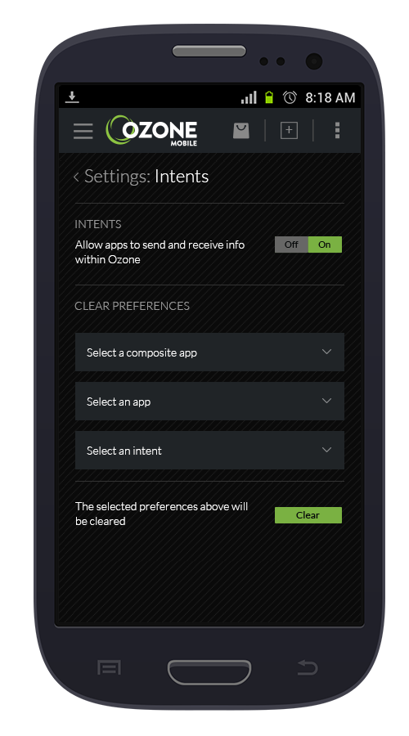

An intent setting is the default component selected to receive data from an intent sender. The intent sender and receiver components are specified in the OWF app component dialog.

➔

➔

3) Once the desired intent preference has been selected, press “Clear” to delete.

2) Select from the 3 available tiers; composite app, an app, or a specific intent preference.

1) On the main “Settings” screen, select the “Intents” option.

## Macintosh HD:Users:ykim:Documents:Mono source files:Developer Toolkit:screens:android-settings-mktplace2.pngMacintosh HD:Users:ykim:Documents:Mono source files:Developer Toolkit:screens:android-settings1.pngMacintosh HD:Users:ykim:Documents:Mono source files:Developer Toolkit:screens:android-settings-mktplace1.pngHow to add an app marketplace

➔

➔

3) The linked/added marketplace will be listed below the “Add” button for future reference.

2) Enter in an apps marketplace url or name in the input field and tap on the “Add” button.

1) On the main “Settings” screen, select the “Marketplace” option.

## How to download apps for offline usage

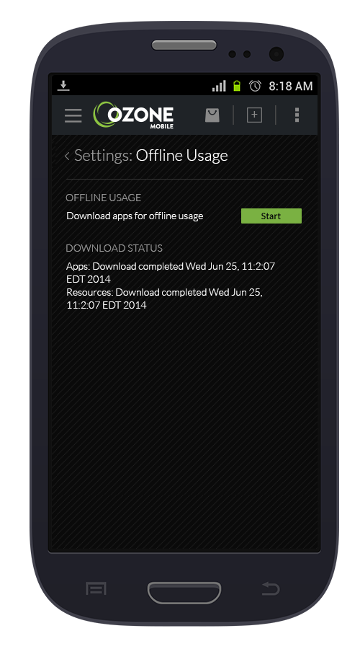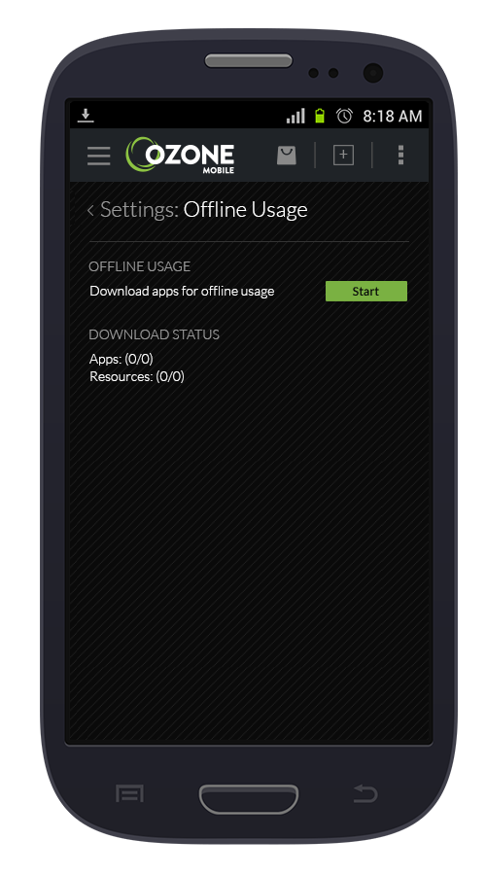

1) Select the “Offline Usage” option on the main “Settings” screen.

Note: Make sure you have installed all the apps you wish to cache for offline usage from the Marketplace.

➔

➔

3) Once Ozone Mobile completes the caching/downloading process, users will see a time stamp for record.

2) Tap on the “Start” button to begin caching. This is a 2-in-1 process where the apps are cached followed by all the resources/data.